**File:** Stanislav_Gospodinov_26_b36abb.rb

Task:

Develop a program named FirstName_LastName_ClassNumber_b36abb.rb

1. you are given an argument for a folder with files;

1.1 if there are other arguments they should be discarded

2. file names in this folder are in the form First_Last_digits.rb;

3. find all the students that have 5 letters in their second name;

4. Sort the result by Last Name ASC.

5. Produce a result in CSV format named result.csv:

FirstName1,LastName1

FirstName2,LastName2

...

FirstNameN,LastNameN

Code:

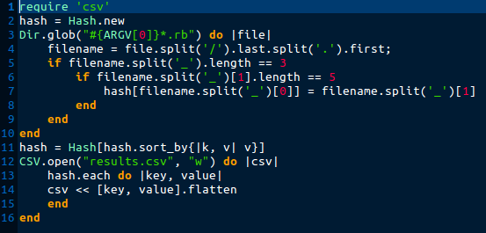

Errors:

* Wrong named CSV file

New code:

